**Requirement Document**

**SoloSphere: Travel Solo, Connect Together**

" SoloSphere is a social app for solo travelers to connect, share experiences, and create memories together. "

Avneet Kaur (300379014), Dan Do (300387931), Shubham Shubham(300352587)

Douglas College

CSIS 3375-001 UX Design in Web & Mobile App

Padmapriya Arasanipalai Kandhadai

Mar 16, 2025

**Requirement Gathering**

* **Purpose or objectives for Requirement Gathering**
  + The objective of requirements gathering is to understand the needs, behaviors, and concerns of solo travelers regarding social travel experiences. Specifically, we aim to
    - Identify the key motivations of solo travelers for seeking companionship.
    - Analyze the biggest challenges and risks associated with solo travel.
    - Evaluate user preferences for travel matching, communication, and social features.
    - Determine essential safety features that users expect in a solo travel app.
    - Assess current methods of connecting with travel companions and the gaps in existing solutions.
* **User study and target sample**
  + Methodology: Online survey and semi-structured interviews.
  + Target audience
    - Primary Users
      * Young solo travelers (late teens to early 30s) who actively engage in solo travel for adventure, self-exploration, or flexibility.
      * Married travelers in their 30s-40s who aspire to travel alone but face challenges due to family responsibilities.
  + Dual Perspective Approach
    - The survey was conducted among both active solo travelers and individuals who want to travel alone but find it difficult.
    - By considering both groups, we can identify what solo travelers truly need and how the app can support them.
  + Survey Scope
    - The research focuses on understanding the essential needs of solo travelers and the features that would enhance their experience.
    - Key areas of interest include safety, social interaction, trip planning, and overcoming barriers to solo travel.
* **Draft of user study survey**
  + The user study survey consists of 25 questions categorized into
    - Demographics: Age, location, travel habits
    - Travel Behavior: Preferred travel styles, duration, and frequency
    - Challenges & Preferences: Solo travel struggles, travel companion compatibility
    - Safety & Security: Privacy concerns, emergency features, verification methods
    - Social & Community Features: How users interact with others while traveling
    - Technology & App Features: Current travel-related apps used, interest in SoloSphere
  + See Appendix A for full survey details.
* **Data Visualization & Analysis**
  + To gain insights into the needs and preferences of solo travelers, we conducted a survey focusing on key areas such as safety, social interaction, trip planning, and challenges of solo travel. Below is an analysis of the collected data.
  + Sample Size: 21 responses from target users
  + Data visualization & analysis
    - Respondent Demographics
      * The majority of respondents belong to the 25-34 age group, followed by the 18-24 category.

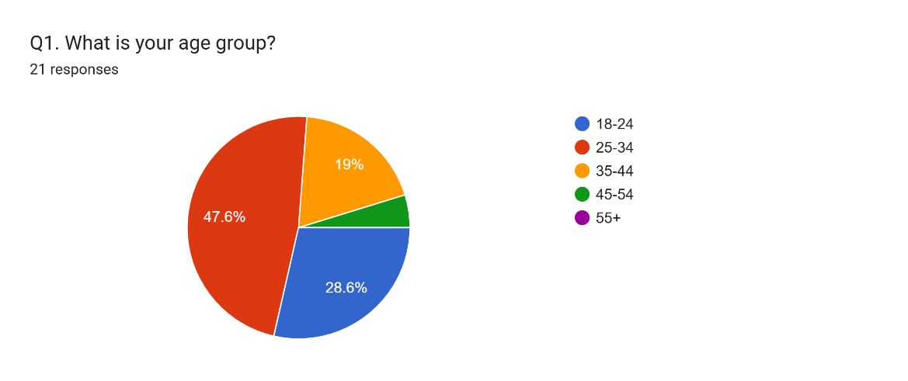

* + - * Most participants reside in North America.

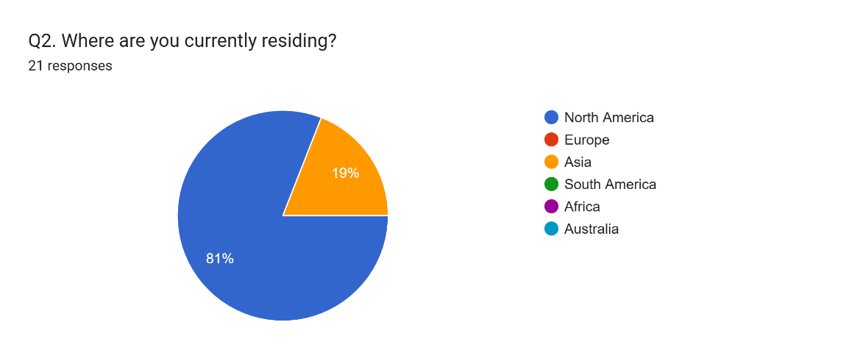

* + - Solo Travel Frequency
      * More than 60% of respondents travel solo at least once a year.

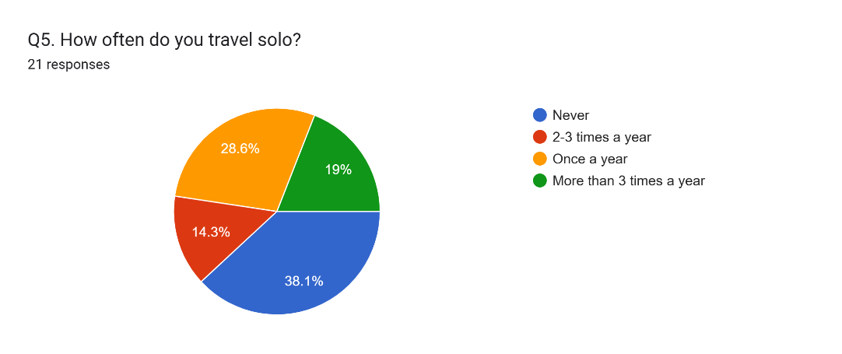

* + - Biggest Challenges of Solo Travel
      * Safety concerns ranked as the highest challenge.

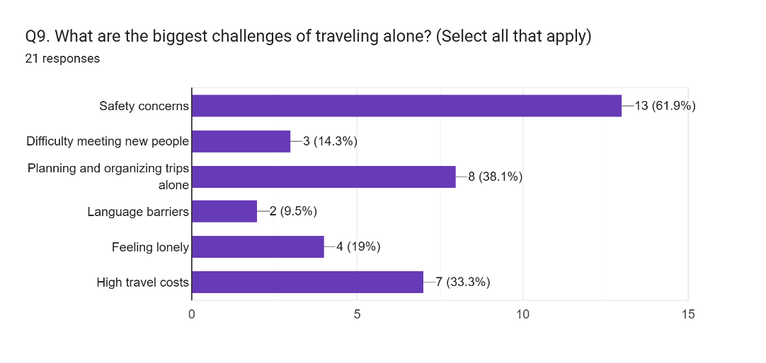

* + - Preferred Solo Travel Styles
      * Popular travel styles: Backpacking, Cultural & city exploration,

Adventure travel (hiking, diving, extreme sports)

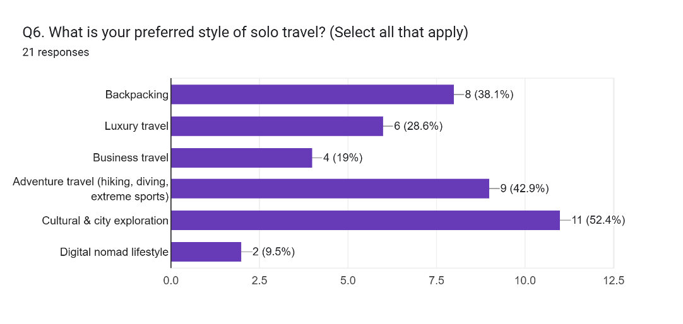

* + - Key Factors When Choosing a Travel Companion
      * Similar interests and activities ranked as the most critical factor.
      * Compatible travel pace and style match also play a major role.

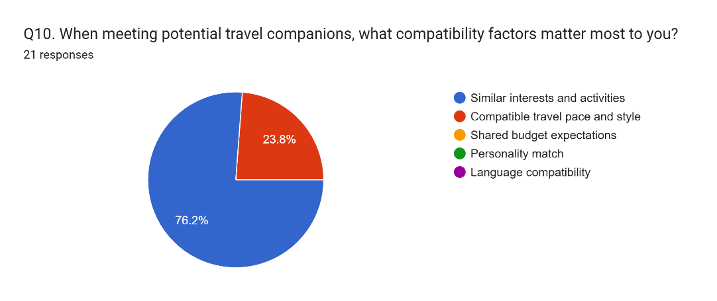

* + - Most Valued Emergency Assistance Features
      * One-touch emergency contact alert and local emergency services information are the top safety features users want.

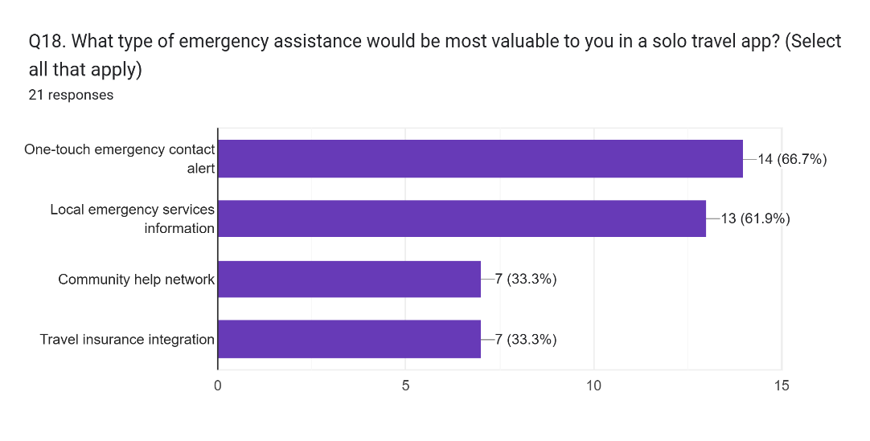

* + - Preferred Features in a Solo Travel App

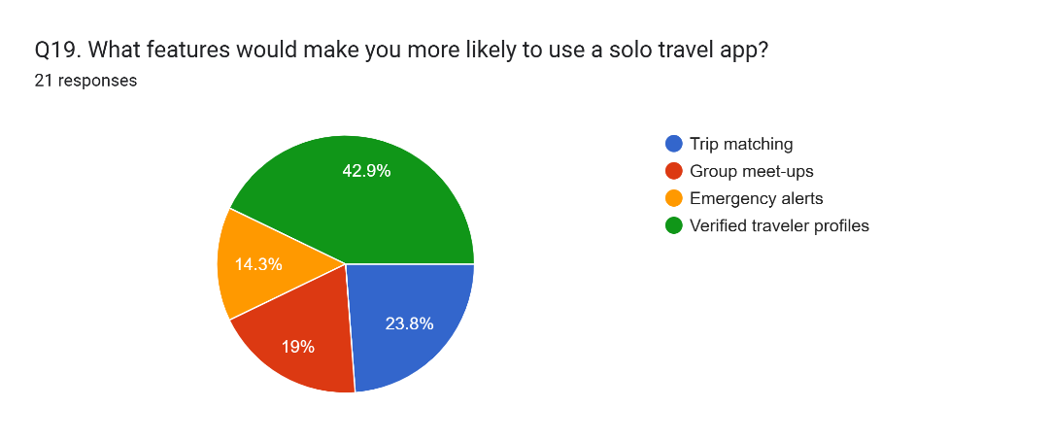

* **Insights from the results**
  + Safety and social interaction are the most critical factors for solo travelers.
  + Users need structured trip planning tools to overcome travel planning difficulties.
  + travel companion matching should prioritize compatibility in interests, travel pace, and personality.
  + Emergency features like SOS alerts, local help, and verification systems are key to user trust.

**Requirement Generation**

* **Personas and scenarios**
  + Community-Driven: The app leverages community reviews, meet-ups, and localized events to foster a supportive network, differentiating it from traditional travel planning apps.
  + First personas and scenarios
    - Daniel Kim – The Cultural Explorer
      * Age: 35
      * Occupation: Senior Software Engineer (Multinational Corporation)
      * Marital Status: Engaged
      * Financial Status: Well-established, has saved a significant amount for travel
      * Travel Frequency: Travels multiple times a year, prefers long solo trips
      * Physical Activity Level: Very active – enjoys hiking, running, and outdoor adventures
      * Personality Traits: Open-minded, adventurous, organized planner
      * Preferred Travel Style: Solo travel with opportunities to meet compatible travelers
    - Scenario: Daniel’s Solo Trip to Japan
      * Daniel has always been passionate about exploring different cultures and landscapes. With his wedding approaching in six months, he wants to maximize his solo travel experiences before settling down.
      * He decides to plan a two-week solo trip to Japan, focusing on Kyoto and Hokkaido.
      * As a solo traveler, Daniel enjoys meeting new people, but past bad experiences with incompatible travel companions make him cautious. He wants to ensure compatibility before traveling with someone.
      * He opens the SoloSphere app and sets up his travel profile, selecting his interests (hiking, cultural exploration, food experiences) and preferences for travel companions.
      * The app suggests potential travel buddies based on shared interests, travel frequency, and personality traits.
      * He finds Lisa, another solo traveler with similar preferences and good past reviews from other travelers.
      * Before deciding to meet, Daniel reviews Lisa’s travel history, past trip experiences, and feedback from other users.
      * They start chatting through the in-app secure messaging feature to discuss their travel plans.
      * Using SoloSphere’s trip planning feature, they create an itinerary together, choosing local meetups, outdoor activities, and sightseeing spots.
      * Daniel books separate accommodations but plans to meet Lisa for shared experiences like a tea ceremony in Kyoto and hiking Mount Fuji.
      * Before departure, Daniel activates SoloSphere’s safety features, including:
        + Real-time location sharing with his fiancée for safety.
        + An emergency SOS button connected to local services.
      * During his trip, he uses SoloSphere’s event discovery feature to join community meetups with other travelers.
      * He documents his journey in SoloSphere’s travel journal feature, sharing insights and photos with the travel community.
      * The trip turns out to be a great experience – Daniel meets like-minded people, avoids mismatched travel companions, and explores Japan stress-free.
  + Second personas and scenarios
    - Sarah Patel – The Family-Oriented Solo Traveler
      * Age: 40
      * Occupation: Marketing Manager
      * Marital Status: Married with two children
      * Financial Status: Well-established, has a comfortable travel budget
      * Travel Frequency: Once a year
      * Physical Activity Level: Moderately active- enjoys sightseeing and cultural experiences
      * Personality Traits: Family-oriented, organized, and prefers structured travel plans
      * Preferred Travel Style: Cultural and city exploration
    - Scenario
      * Sarah has always loved art and history, and she dreams of discovering Europe's rich cultural heritage. As a hardworking marketing manager and a devoted mother of two, she struggles to juggle family duties with her desire to travel. Still, she is committed to taking a solo trip to Europe to pursue her passion for exploring different cultures.
      * Sarah's Solo Trip to Europe

* + Third personas and scenarios
    - Emma Collins
      * Age: 26
      * Occupation: Marketing Consultant (Remote)
      * Location: New York, USA
      * Travel Style: Solo traveler, loves history, cultural experiences, and meeting new people safely.
      * Pain Points:
        + Struggles to find trustworthy travel companions.
        + Concerned about safety when exploring unfamiliar places alone.
        + Prefers local insights over generic tourist experiences.
    - Scenario: Emma’s Solo Adventure in Egypt with Solosphere
      * Emma had always dreamed of visiting Egypt, but the thought of exploring alone made her hesitant. After landing in Cairo, she opened Solosphere and found a verified group planning a visit to the Pyramids of Giza. One of them, Youssef, a local history enthusiast, had great reviews for sharing unique insights beyond standard tours.
      * Before joining, Emma used Solosphere’s in-app chat to introduce herself and discuss the plan with the group, making her feel more comfortable. Feeling reassured by SoloSphere’s safety features, she checked Youssef’s profile, shared her live location with a friend, and set a check-in reminder before heading out.
      * As they explored the pyramids, she bonded with fellow travelers, learning hidden details about the site. Later, they continued their conversations over tea at a local café, exchanging travel tips and planning their next adventure together. For the first time, Emma truly felt that solo travel didn’t mean being alone.
* **Requirements Generation**
  + User Authentication & Secure Profile Creation
  + Location-based Travel Companion Matching
  + AI-Based Smart Recommendations
  + Secure In-App Messaging (Private & Group Chat)
  + Emergency Assistance Features (One-touch SOS & Trusted Contacts)
  + Trip Planning & Itinerary Sharing
  + Community Meet-Ups & Verified Reviews
  + User Ratings & Reviews for Travel Companions
  + Multi-Language Support for International Travelers
  + Privacy & Safety-First Travel Experience
  + Group Travel & Social Networking Features
  + Verified Local Guides & Experts
  + Solo-Friendly Accommodation & Transport Suggestions
  + Offline Mode and Smart Itinerary Syncing
  + Expense Splitting and Group Budgeting tools
  + Verified Women’s Travel Network

**Synthesis of requirement gathering and generation**

* By combining insights from user surveys and the requirements generation process, we categorized and prioritized key requirements.
  + Must-Have Features (Essential for Core Functionality)
    - Secure user authentication and verification (ID, social media linking, ratings).
    - AI-driven travel companion matching based on interests, travel style, and pace.
    - Secure, encrypted in-app messaging system for private communication.
    - Emergency assistance tools: one-touch SOS, real-time location sharing, local emergency contacts.
    - Trip planning and itinerary-sharing tools for structured travel experiences.
    - A dynamic trust score based on user activity, ratings, successful meet-ups, and safety reports.
    - Dark Mode & Low-Light UI Optimization
    - Automatically adjusts trip details, event timings, and currency calculations based on the user's current location.
    - Offline mode with pre-synced key data like itineraries, safety contacts, and chats for remote use.
    - Verified Women’s Travel Network, offering women-only group options and added verification.
  + Should-Have Features (Enhancing Usability & Safety)
    - User ratings and review system to assess trustworthiness.
    - Community meet-up features for local and group activities.
    - Multi-language support for global accessibility.
    - Filter options to find travelers based on budget, fitness level, and travel goals.
    - Expense splitting and budgeting tools for transparent cost sharing among companions.
    - Converts expenses into the user’s preferred currency.
    - Users can create visual travel boards with saved destinations, experiences, and itineraries.
  + Could-Have Features (Additional Functionalities for Expansion)
    - Integration with third-party travel services (Airbnb, local guides, tour services).
    - Augmented reality (AR) meet-up discovery for real-world connections.
    - AI-powered chat assistant for real-time trip recommendations.
    - Syncs with smartwatches or fitness bands to provide real-time alerts on trip changes, safety warnings, or meeting reminders.
    - Users earn badges for sustainable actions like avoiding plastic, using public transport, or engaging in conservation activities.

**Conclusions from the Requirement Analysis Process**

* Safety and trust are top priorities for solo travelers, influencing core security features.
* AI-driven personalization is crucial for better travel buddy matching.
* A hybrid model of structured planning and spontaneous meet-ups improves the travel experience.
* Localization (language support, cultural preferences) enhances SoloSphere’s accessibility and usability globally.
* Wearable tech, AR-guided experiences, and AI travel assistants add long-term value.
* Users feel safer when they have control over their privacy settings and visibility.
* Multi-language support, cultural guides, and region-specific safety insights make the app truly global.
* Offline functionality and transparency in expense management improve both safety and social dynamics during trips

**Work Date/Hours Logs**

* **Avneet Kaur**

|  |  |  |
| --- | --- | --- |
| **Date** | **Number of Hours** | **Description of work done** |
| Jan 25, 2025 | 2 | Searching for project ideas and finalizing |
| Jan 30, 2025 | 1 | An idea confirmation meeting |
| Jan 31, 2025 | 1.5 | Review GitHub repo |
| Feb 4, 2025 | 2 | Tried making changes to the README document, but I wasn’t able to. Then asked Dan for help |
| Feb 5, 2025 | 1 | Finalize proposal document |
| Feb 8, 2025 | 2.5 | Created a Figma account and completed an introductory exercise to understand the interface |
| Feb 12, 2025 | 4 | Designed a simple mobile app login screen in Figma to explore features like frames, text tools, and prototyping. |
| Feb 16, 2025 | 1.5 | Watched the "UserStudy_RequirementGathering" video and reviewed the accompanying slides |
| Mar 2, 2025 | 1 | Discuss with group members to decide whether to go with survey or interview, and we decided to take surveys of users |
| Mar 5, 2025 | 3 | Brainstormed different survey questions individually and then analyzed and finalized the questionnaire |
| Mar 6, 2025 | 1 | Talked to a few users and sent them the Google Form survey for responses. |
| Mar 11, 2025 | 0.5 | Review draft requirement gathering document |
| Mar 11, 2025 | 2 | Developed personas and scenarios for requirement generation |
| Mar 12, 2025 | 3 | Convert scenario into storyboard |
| Mar 15, 2025 | 3 | Conduct requirement generation based on personas and review team-created requirement generations |

* **Dan Do**

|  |  |  |
| --- | --- | --- |
| **Date** | **Number of Hours** | **Description of work done** |
| Jan 24, 2025 | 3 | Project Idea Initiative |
| Jan 30, 2025 | 1 | An idea confirmation meeting |
| Jan 30, 2025 | 2 | Create GitHub repo |
| Jan 30, 2025 | 0.5 | Update README file |
| Feb 1, 2025 | 6 | Write Project Proposal draft version |
| Feb 5, 2025 | 1 | Finalize proposal document |
| Feb 18, 2025 | 2 | Explored Figma features, including design tools, prototyping, and collaboration functionalities |
| Feb 20, 2025 | 1 | Downloaded and explored apps such as TravelBuddy, Meetup, Tinder, and Couchsurfing to analyze their features and functionalities relevant to Solo Sphere |
| Feb 21, 2025 | 2 | Reviewed a Requirement Gathering video to ensure a clear understanding of the requirement gathering process |
| Mar 1, 2025 | 1 | Brainstormed ideas for requirements gathering |
| Mar 2, 2025 | 1 | Collaborated with team members to refine the survey structure, determine appropriate question formats (MCQs, rating scales, open-ended), and identify the best approach for gathering meaningful user feedback |
| Mar 5, 2025 | 3 | Collaboratively reviewed the survey questions proposed by each team member, eliminated duplicates, and categorized them based on key themes |
| Mar 6, 2025 | 3 | Created the survey form using Google Forms based on the finalized questions and distributed it to the target user group |
| Mar 10, 2025 | 2 | Developed personas and scenarios for requirement generation |
| Mar 11, 2025 | 3 | Drafted the initial requirement gathering document based on survey results |
| Mar 12, 2025 | 3 | Reviewed team-created personas and scenarios to prepare for requirement generation |
| Mar 13, 2025 | 3 | Conducted requirement generation based on three finalized personas and scenarios |

* **Shubham Shubham**

|  |  |  |
| --- | --- | --- |
| **Date** | **Number of Hours** | **Description of work done** |
| Jan 30, 2025 | 1 | An idea confirmation meeting |
| Feb 2, 2025 | 1.5 | Refined background research, expanded competitor analysis |
| Feb 3, 2025 | 1.5 | Improved "Technologies Needed" section, added Figma |
| Feb 3, 2025 | 0.5 | Enhanced value proposition and preliminary features list |
| Feb 3, 2025 | 0.5 | Formatting of Word Document |
| Feb 5, 2025 | 1 | Finalize proposal document |
| Feb 9, 2025 | 2 | Exploring Figma and its features (  wireframing, prototyping) |
| Feb 12, 2025 | 2.5 | Trying a small demo on Figma |
| Feb 16, 2025 | 2 | Reviewed the **Requirement Gathering** video and analyzed the key tasks needed for the survey. Identified best practices for designing effective surveys. |
| March 2, 2025 | 1 | Discussed with team members about the survey structure, types of questions to include (MCQs, rating scales, open-ended), and the best way to collect relevant user feedback. |
| March 3, 2025 | 3 | Created an independent set of questions to ensure coverage of all aspects of solo travel. Cross-checked against team inputs for completeness. |
| March 5, 2025 | 1.5 | Filtered and refined survey questions by removing duplicates, selecting the best ones, and ensuring clarity and logical flow. |
| March 5, 2025 | 1 | Continuing practicing Figma components (UI design principles) |
| March 7, 2025 | 1 | Monitored survey responses, collected initial data |

**Appendix A**

* SoloSphere User Survey
  + Thank you for participating in this survey! This survey aims to understand solo travelers' needs and preferences to design a better travel companion app.
  + Estimated time to complete: 10 minutes
    - Demographics - 3 Questions
      * Q1. What is your age group?
        + 18-24
        + 25-34

35-44

* + - * + 45-54
        + 55+
      * Q2. Where are you currently residing?
        + North America
        + Europe
        + Asia
        + South America
        + Africa
        + Australia
      * Q3. What is your gender?
        + Male
        + Female
        + Non-binary / Prefer not to say
    - Travel Behavior - 5 Questions
      * Q4. What is your preferred solo travel duration?
        + Weekend trips (1-3 days)
        + Short trips (4-7 days)
        + Medium trips (1-2 weeks)
        + Extended trips (more than 2 weeks)
      * Q5. How often do you travel solo?
        + Never
        + Once a year
        + 2-3 times a year
        + More than 3 times a year
      * Q6. What is your preferred style of solo travel? (Select all that apply)
        + Backpacking
        + Luxury travel
        + Business travel
        + Adventure travel (hiking, diving, extreme sports)
        + Cultural & city exploration
        + Digital nomad lifestyle
        + Other (please specify) _______
      * Q7. Why do you choose to travel alone? (Select all that apply)
        + Freedom to explore at my own pace
        + Opportunity to meet new people
        + Personal growth and self-discovery
        + Work or business-related travel
        + Couldn’t find travel partners
        + Other (please specify) _______
      * Q8. How do you currently find travel companions when traveling solo? (Select all that apply)
        + Friends
        + Social media
        + Travel companion apps/websites
        + I usually prefer to travel alone
        + Other (please specify) _______
    - Challenges & Preferences - 5 Questions
      * Q9. What are the biggest challenges of traveling alone? (Select all that apply)
        + Safety concerns
        + Difficulty meeting new people
        + Planning and organizing trips alone
        + Language barriers
        + Feeling lonely
        + High travel costs
        + Other (please specify) _______
      * Q10. When meeting potential travel companions, what compatibility factors matter most to you?
        + Similar interests and activities
        + Compatible travel pace and style
        + Shared budget expectations
        + Personality match
        + Language compatibility
      * Q11. What travel style best describes you?
        + Adventure seeker
        + Cultural explorer
        + Relaxation focused
        + Budget traveler
        + Luxury traveler
      * Q12. How important is having a shared travel itinerary feature in the app?
        + Not important
        + Somewhat important
        + Important
        + Very important
      * Q13. Would you be interested in location-based notifications about other solo travelers nearby?
        + Yes, always
        + Yes, but only after I approve them
        + Only in specific situations
        + No, I prefer to initiate all connections
    - Safety & Security - 5 Questions
      * Q14. What features do you look for in a travel app? (Select all that apply)
        + Navigation
        + Trip planning
        + Social networking
        + Safety features
        + Other (please specify) _______
      * Q15. Would you feel more secure and safe if the app had real-time location sharing with trusted contacts?
        + Yes
        + No
      * Q16. What is your biggest concern about using technology to meet travel companions?
        + Privacy of my personal data
        + Authenticity of other users
        + Ability to disconnect if needed
        + Technical reliability while traveling
        + Other (please specify) _______
      * Q17. How would you prefer to verify another traveler's identity?
        + Government ID verification
        + Social media profile linking
        + Video call verification
        + References from other travelers
        + Professional/educational verification
      * Q18. What type of emergency assistance would be most valuable to you in a solo travel app? (Select all that apply)
        + One-touch emergency contact alert
        + Local emergency services information
        + Community help network
        + Travel insurance integration
    - Social & Community Features - 4 Questions
      * Q19. What features would make you more likely to use a solo travel app?
        + Trip matching
        + Group meet-ups
        + Emergency alerts
        + Verified traveler profiles
        + Other (please specify) _______
      * Q20. How would you like to share your travel experiences within the app? (Select all that apply)
        + Photo galleries
        + Written travel journals
        + Short video clips
        + Interactive maps of places visited
        + I prefer not to share my experiences
      * Q21. How do you usually meet new people while traveling? (Select all that apply)
        + Join travel meet-up events
        + Use travel companion apps or websites
        + Stay in hostels / shared accommodations
        + Engage with locals through cultural experiences
        + Social media or online communities
        + I usually prefer to travel alone
      * Q22. How would you prefer to interact with other travelers through an app?
        + Private one-on-one chat
        + Public community forums / social feed
        + Group chat based on location or travel plans
        + Organized group meet-ups
        + I am not interested in connecting with other travelers
    - Technology & App Features - 3 Questions
      * Q23. Which travel-related apps do you currently use? (Select all that apply)
        + Google Maps
        + Airbnb
        + Couchsurfing
        + Meetup
        + Tinder
        + None of the above
        + Other (please specify) _______
      * Q24. If an app like SoloSphere existed, would you consider using it?
        + Yes
        + No
        + Not Sure
      * Q25. Do you have any additional comments or suggestions for SoloSphere? (Optional)
        + "What additional features would you like to see in a solo travel app like SoloSphere? Do you have any concerns, suggestions, or ideas to improve the app? Feel free to share your thoughts!"